Leveraging Large Language Models for the Automated Generation of Educational Quizzes Based on SOLO Taxonomy
  - Uroš Petrašković 1
  - Uroš Petrašković ¹, Goran Savić ¹*, Mihaela Osmajić ¹, Milan Segedinac ¹, Peter Steiner ²
  - ¹ University of Novi Sad, Faculty of Technical
Sciences, Trg Dositeja Obradovića 6, 21000 Novi Sad, Serbia
  - ² Pädagogischen Hochschule St.Gallen (PHSG), Notkerstrasse 27,
9000 St.Gallen, Switzerland

  - * Corresponding author's e-mail: savicg@uns.ac.rs

ORCID IDs
- Uroš Petrašković - https://orcid.org/0009-0005-5193-5089
- Goran Savić - https://orcid.org/0000-0002-3917-5487
- Mihaela Osmajić - https://orcid.org/0009-0003-9712-1756
- Milan Segedinac - https://orcid.org/0000-0003-1743-9522
- Peter Steiner - https://orcid.org/0009-0001-5491-9464
Abstract
Creating high-quality educational assessments manually is a labor-intensive and cognitively demanding process for educators. This paper introduces an automated system for generating educational quizzes by integrating the Structure of Observed Learning Outcomes (SOLO) taxonomy with ontology-based knowledge representation. The system automatically extracts hierarchical course structures from raw learning materials. By leveraging Large Language Models (LLMs), it then generates a comprehensive pool of questions that span various cognitive depths, from unistructural to extended abstract, as defined by the SOLO framework. We present the technical architecture of our solution alongside a qualitative evaluation of the generated questions.
Keywords
Automatic Question Generation, SOLO Taxonomy, Ontology, LLM

Introduction
Education has always played a fundamental role in society and as technology becomes an increasingly integral part of our lives, there is a growing need for tools that can assist both: teachers and students. One of the challenges teachers face is the creation of quizzes and assessments. Developing effective questions, especially those designed to test different levels of student understanding, is a significantly time-consuming process.
This project addresses these challenges by developing an automated system designed to transform educational content, i.e. lecture notes in PDF format, into structured assessments. Unlike generic question generators, this system categorizes questions according to the Structure of Observed Learning Outcome (SOLO) taxonomy [1]. This framework allows for the generation of questions at varying cognitive levels, enabling a personalized learning experience where quizzes are adapted to a student's specific depth of understanding. To represent underlaying knowledge structure, the system utilizes ontologies [2] which formally describe the relationships between concepts providing a structured understanding of the material.
The SOLO taxonomy, developed by Biggs and Collis [3], provides a framework for categorizing the increasing complexity of a learner's understanding. It consists of five distinct levels: (1) Prestructural, where the student does not really understand the topic yet; (2) Unistructural, where they understand one aspect; (3) Multistructural, where they understand several aspects but do not see how they connect; (4) Relational, where they can integrate different pieces into a coherent whole; and (5) Extended Abstract, where they can generalize and apply the knowledge to new situations. Building on this hierarchy, our system utilizes an LLM to generate questions of varying cognitive complexity, conditioned on the specific scope of the course structure provided as LLM context during the generation process.
The rest of the paper is organized as follows: First we offer a review of related work in the field of automatic question generation. Then we detail the system architecture and implementation, describing the technical solutions developed for this project. Manual evaluation of the generated questions is given in the Discussion section, while the last section presents concluding remarks and directions for future research.

Related Work
The field of Automatic Question Generation has evolved significantly over the past two decades. One of the foundational works was by Mitkov and Ha [4], who developed a system that used natural language processing rules to transform declarative sentences into questions. Their approach could take a sentence like "Photosynthesis occurs in chloroplasts" and generate "Where does photosynthesis occur?" While effective for simple factual content, these rule-based systems struggled with complex material and often produced grammatically awkward questions.
More recently, Kasneci et al. [5] published a comprehensive review of using LLMs like ChatGPT in education. They highlighted both the potential and the risks, noting that while these models can generate diverse questions quickly, they also raise concerns about accuracy, bias, and the need for teacher oversight. Lister et al. [6] (2006) examined how the SOLO taxonomy could be applied to classify and evaluate programming questions. Their seminal work, "Not seeing the forest for the trees: novice programmers and the SOLO taxonomy," revealed a critical insight: many programming education assessments focus too heavily on low-level skills (identifying syntax errors, recognizing code fragments) while neglecting higher-order thinking skills (integrating concepts, designing solutions). They demonstrated that exam questions could be systematically classified into SOLO levels, from uni-structural questions that test single concepts like "What does this variable store?" to extended abstract questions like "Design a program that solves this complex problem using multiple data structures." Their framework provides a structured way to ensure that questions across all complexity levels are included.
One important aspect in automatic generation of multiple-choice questions is the quality of the provided wrong answers. The challenge of generating good distractors has analyzed in Liang et al. [7], who proposed using a "learning to rank" approach where the system generates many candidate distractors and then ranks them by how plausible they are. Their key insight was that good distractors should be semantically related to the correct answer but clearly wrong upon careful reading. For example, if the correct answer is "mitochondria," good distractors might be "ribosomes" or "nucleus" rather than some other unrelated phrase.

Solution
The system is implemented as a web application consisting of a three-tier monolithic architecture. Its primary function is the automated creation of educational assessments based on the SOLO taxonomy, achieved through a defined data processing pipeline that transforms raw materials into structured quizzes (Figure 1).
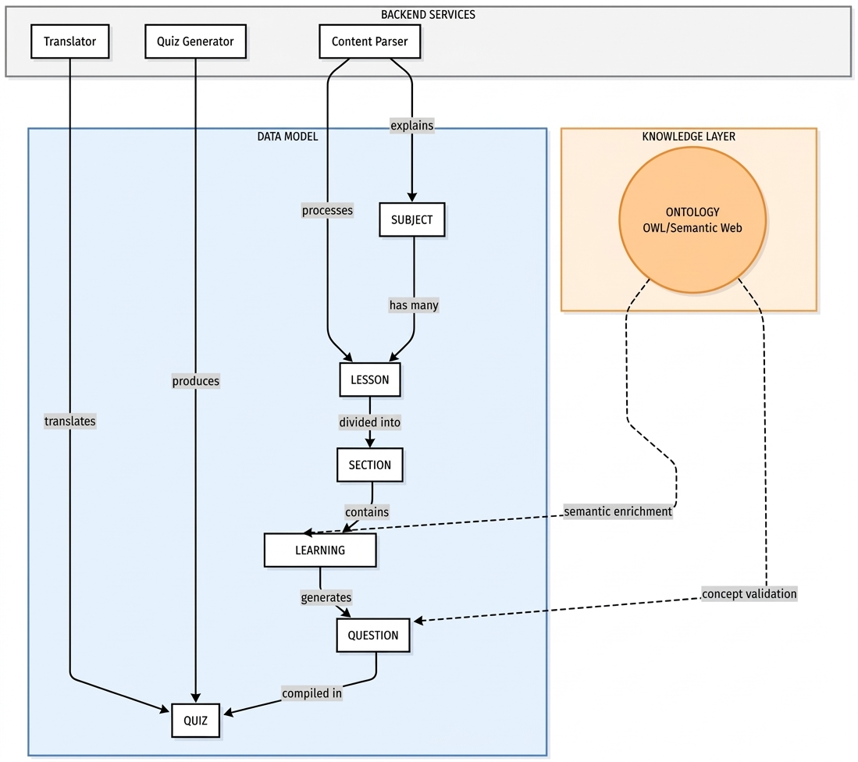
Figure 1 - Workflow diagram
The process begins with the ingestion of course learning material in PDF format, after which the text is sent to the LLM model for parsing into logical components. While our architecture is model-agnostic, for the purpose of this research we used local Qwen 2.5 model. The model automatically extracts course structure from raw course material and stores it into a database as a hierarchical structure: a Course contains Lessons, Lessons contain Sections and Sections contain specific Learning Objects. Once all learning objects are created, the system automatically establishes ontological relationships between them, which can then be exported as an OWL file. These relationships serve as additional information that enables the user to visualize the knowledge graph, showing nodes and edges that represent concepts and their relationships, thus providing a clear overview of the curriculum's semantic map.
The question generation process utilizes the Qwen 2.5 with 14 billion parameters, executed via the Ollama framework. This model can be run on the local machine without needing an internet connection or API keys. The system iterates through the stored learning objects and ontological relationships to generate questions corresponding to four SOLO levels. Each level corresponds to a different type of question. Unistructural questions ask about a single fact. Multistructural questions ask about multiple facts. Relational questions ask how things connect and Extended Abstract questions ask students to apply what they learned in a new context. Each level is achieved by applying level-specific prompts, adapted to the required cognitive complexity. Every generated question is stored in the database along with its multiple-choice options, the correct answer and a detailed explanation. Every question can be automatically translated using the Translator module.
The resulting question pool serves as the foundation for automated quiz construction. To generate an assessment, the educator selects the desired topics and specifies the required number of questions for each SOLO level (Figure 2).
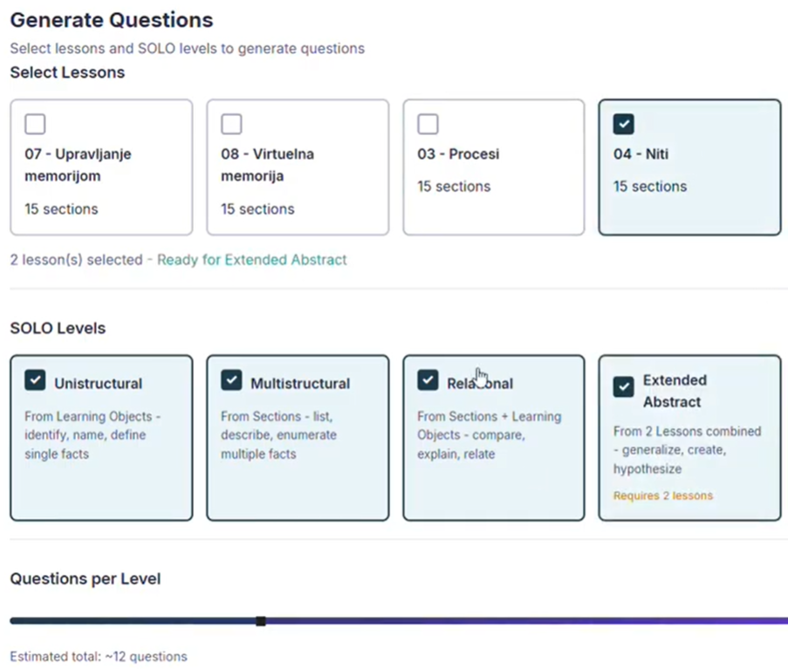
Figure 2 - Setting parameters for a quiz
Figure 3 illustrates a sample quiz as it appears within the system's end-user interface.
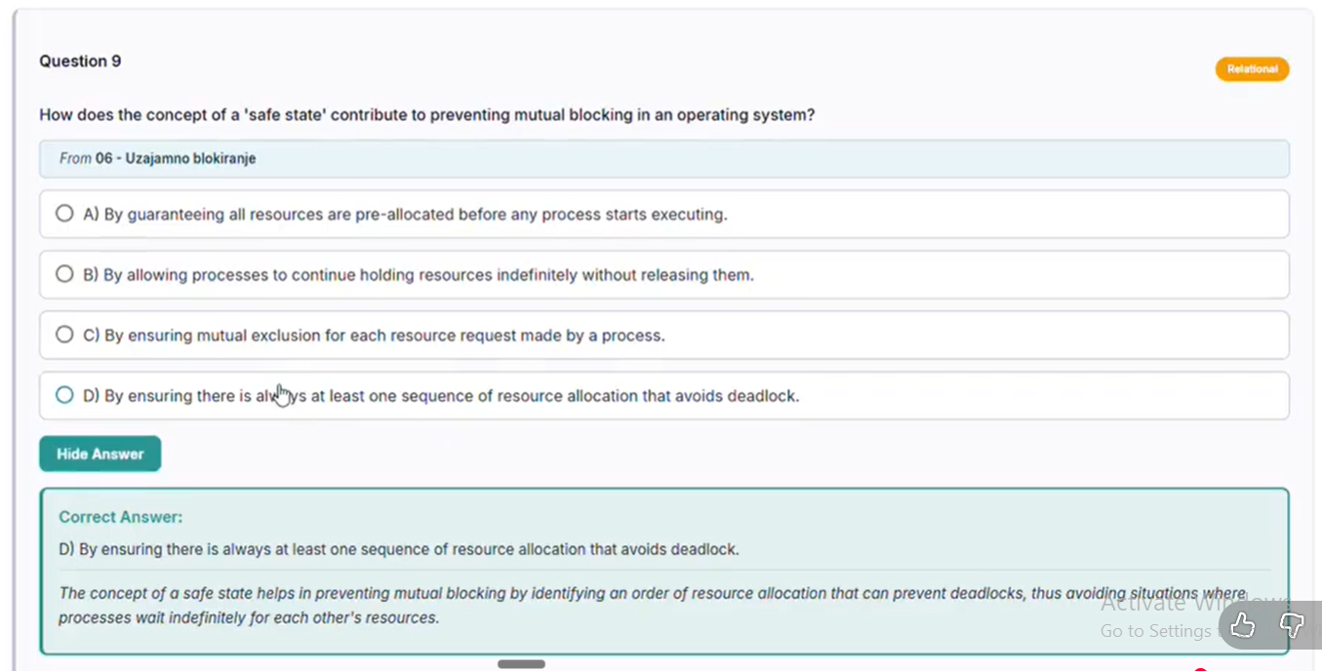
Figure 3 - An educational quiz in accordance with SOLO taxonomy

Discussion
In this section we discuss the quality of generated questions by taking one representative example for each SOLO level. As a case study, we took learning material from two undergraduate courses: Operating systems, and Software testing. The assessment focused on two primary criteria: first, the alignment of each question with its assigned SOLO level, and second, the plausibility of the distractors to ensure they effectively challenge learners and prevent the easy elimination of incorrect options.

Unistructural Questions
Questions generated at the unistructural level generally succeeded in isolating single, fundamental concepts, which is the primary requirement for this taxonomic stage. For example, the system produced the following item: "The Program Counter (PC) holds the memory address of which type of entity?" with the correct answer being: A) The next instruction to be executed.
The evaluation of this item’s distractors revealed variable quality of our system. Option B (The current executing instruction) proved particularly effective by exploiting a temporal confusion between "next" and "current," accurately targeting students with an incomplete understanding of the fetch-execute cycle. Option C (All instructions in memory) addressed a common novice misconception regarding register scope, although it may be obvious for students aware that registers hold singular values. Option D (Data variables) was identified as the weakest distractor, as students with basic architectural knowledge could easily distinguish between instruction and data addresses, leading to its rapid elimination.

Multistructural questions
Questions at the multistructural level require students to handle multiple independent aspects of a topic, typically through comparison or the identification of several correct characteristics. For instance, the system generated the following item: "Which of the following statements correctly describe both User-Level Threads (ULT) and Kernel-Level Threads (KLT)?" with the correct answer being: A) ULT are managed by application, KLT by OS; ULT can provide finer control but may be less efficient than KLT.
The evaluation of this item’s distractors showed a successful attempt at targeting complex misconceptions. Option B (Both ULT and KLT require explicit synchronization mechanisms to prevent race conditions) appeared highly plausible as synchronization is a genuinely relevant topic in threading. However, it incorrectly universalizes a concern that varies significantly by implementation. Option D (Kernel manages both ULT and KLT, providing equal efficiency and control) effectively targeted the misconception that kernel-level management automatically equalizes all thread characteristics. Option C (ULT provides more system resources allocation units compared to KLT) was identified as the weakest distractor. Its phrasing was found to be too technical and sufficiently vague that students might eliminate it based on unclear wording rather than a true understanding of thread resource allocation.

Relational Questions
For discussing the quality of generating relational questions, as a representative example we will take the question "How does test automation contribute to the effectiveness of regression testing?" The generated options were: A) Test automation only improves the speed of functional testing without impacting regression testing, B) Test automation replaces manual testing entirely, making regression testing unnecessary, C) Test automation allows for faster execution and identification of changes in functionality, enhancing the thoroughness of regression tests, D) Test automation focuses on creating new test cases rather than running existing ones efficiently. The correct answer is C.
The question requires students to connect two concepts - understanding both what regression testing entails (re-executing existing tests to detect unintended changes) and how automation specifically addresses its challenges. With regard to distractors, option B captures an extreme misconception about automation replacing human judgment entirely, while Option A creates an artificial boundary between functional and regression testing that might appeal to students with lesser understanding. However, regarding the Option D, the claim that "test automation focuses on creating new test cases" doesn't align with any common misconception about automation - most students would recognize that automation executes tests rather than generates them. This makes the distractor too easily eliminated. Additionally, Option A's specificity about "only functional testing" may be overly obvious, as students familiar with basic automation concepts would recognize that automated tests can serve multiple purposes. Stronger distractors might address misconceptions about automation coverage limitations or the false belief that automated tests detect different types of defects than manual regression testing.

Extended abstract questions
Questions at the extended abstract level are designed to test the student's ability to generalize and apply learned concepts to new, more complex domains. For instance, the system generated the following item: "In a distributed computing environment, if a main process spawns multiple child processes across different nodes, what mechanism ensures that all child processes receive the correct system resources and do not interfere with each other?" with the correct answer being: A) Implementing inter-process communication (IPC) protocols to manage resource allocation and synchronization.
The evaluation of this question shows that it successfully takes the concept of process management, typically learned in a single-machine context and requires the student to extend it to a distributed environment. The distractors exhibited a mix of effectiveness in targeting reasoning errors. Option C (Allocating all child processes to a single node for centralized management of resources) effectively identifies a common misconception where students assume that centralization is a viable solution for management, despite it defeating the purpose of distribution. Option D (Using thread-level synchronization techniques within each individual node) correctly recognizes a partial truth, as thread synchronization addresses only intra-node concerns rather than the broader distributed problem. Option B (Increasing the priority of the parent process over its children to control their execution flow) was identified as too obviously incorrect. The idea of "increasing priority" does not logically connect to resource allocation or interference prevention across nodes, making it easily eliminated and reducing the overall challenge of the item.

Limitations Found
The evaluation revealed several systematic limitations in the question generation process. A clear pattern emerged across cognitive levels: as the taxonomic complexity increased from unistructural to extended abstract, question quality deteriorated. Lower-level questions (unistructural and multistructural) generally demonstrated stronger alignment with their intended cognitive levels. However, higher-level questions, particularly at the relational and extended abstract levels, exhibited significant validity concerns. The correct answers themselves sometimes contained technical inaccuracies or oversimplifications.
Distractor quality also declined at higher cognitive levels. While unistructural questions typically featured distractors targeting genuine misconceptions, extended abstract questions often included options that were either trivially eliminable (violating fundamental principles obvious to any competent student) or failed to reflect realistic reasoning errors students might make when extending concepts to new domains. Additionally, distractor redundancy emerged as a recurring issue, with multiple options sometimes conveying essentially the same incorrect concept, reducing the discriminatory power of the assessment items.

Conclusion
This paper presented a system for the automated generation of educational quizzes grounded in the SOLO taxonomy. By integrating Large Language Models (LLMs) with Semantic Web technologies and an intuitive user interface, the system enables educators to develop assessments with significantly reduced manual effort. Preliminary results indicate that the generated questions generally align with their intended SOLO levels and feature distractors sufficiently plausible to evaluate genuine conceptual understanding. While higher cognitive levels occasionally present challenges regarding question validity and distractor variety, the overall performance remains consistent. Nonetheless, certain limitations were identified, particularly concerning the nuance and variety of generated incorrect options.
Future work will focus on refining distractor generation to ensure higher pedagogical utility. Additionally, expanding the system to process more complex and diverse learning materials will further enhance its practical application for instructors. Given the generative versatility of LLMs, we also plan to extend the system’s capabilities beyond multiple-choice questions to include formats such as short-answer and essay prompts.

Acknowledgments
This research has been supported by the Ministry of Science, Technological Development and Innovation (Contract No. 451-03-34/2026-03/200156) and the Faculty of Technical Sciences, University of Novi Sad through project “Scientific and Artistic Research Work of Researchers in Teaching and Associate Positions at the Faculty of Technical Sciences, University of Novi Sad 2026” (No. 01-3609/1).

References
[1] | Chan, C.C., Tsui, M.S., Chan, M.Y. and Hong, J.H., 2002. Applying the structure of the observed learning outcomes (SOLO) taxonomy on student's learning outcomes: An empirical study. Assessment & Evaluation in Higher Education, 27(6), pp.511-527.
[2] | Smith, B., 2012. Ontology.
[3] | Biggs, J. and Collis, K., 1989. Towards a model of school-based curriculum development and assessment using the SOLO taxonomy. Australian journal of education, 33(2), pp.151-163.
[4] | Mitkov, R., 2003. Computer-aided generation of multiple-choice tests. In Proceedings of the HLT-NAACL 03 workshop on Building educational applications using natural language processing (pp. 17-22).
[5] | Kasneci, E., Seßler, K., Küchemann, S., Bannert, M., Dementieva, D., Fischer, F., Gasser, U., Groh, G., Günnemann, S., Hüllermeier, E. and Krusche, S., 2023. ChatGPT for good? On opportunities and challenges of large language models for education. Learning and individual differences, 103, p.102274.
[6] | Lister, R., Simon, B., Thompson, E., Whalley, J.L. and Prasad, C., 2006. Not seeing the forest for the trees: novice programmers and the SOLO taxonomy. ACM SIGCSE Bulletin, 38(3), pp.118-122.
[7] | Liang, C., Yang, X., Dave, N., Wham, D., Pursel, B. and Giles, C.L., 2018, June. Distractor generation for multiple choice questions using learning to rank. In Proceedings of the thirteenth workshop on innovative use of NLP for building educational applications (pp. 284-290).

